Aim: **Design a system for home security systems, such that whenever someone approaches the gate, the LED starts blinking once every 100 ms**

**Circuit Diagram:**

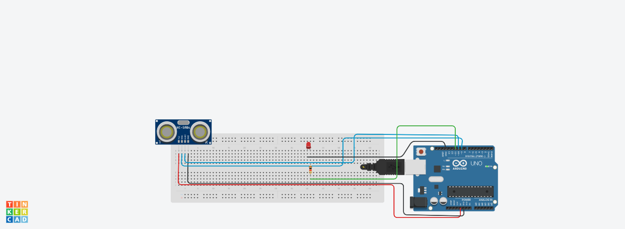

Theory:

 Concept Used :The ultrasonic sensor used in this problem is used as a distance sensor, it will tell us the distance at which the object is placed. Using this distance value, we will turn the led on or off.

Program Code :

int trigger_pin = 9;

int echo_pin = 10;

int led = 11;

int time;

int distance;

void setup( ) {

Serial.begin (9600);

pinMode (trigger_pin, OUTPUT);

pinMode (echo_pin, INPUT);

pinMode (led , OUTPUT);

}

void loop( ) {

digitalWrite(trigger_pin, HIGH);

delayMicroseconds(10);

digitalWrite(trigger_pin, LOW);

time=pulseIn(echo_pin, HIGH);

distance=(time * 0.034) / 2;

if(distance<= 10)

{

Serial.println(" Door Open ");

Serial.print(" Distance= ");

Serial.println(distance);

digitalWrite(led , HIGH);

delay(100);

}

else {

Serial.println(" Door closed ");

Serial.print(" Distance= ");

Serial.println(distance);

digitalWrite(led , LOW);

delay(500);

}

}

Problems & Troubleshooting:

The Code of the circuit is correct but hardware is not working then i change the connections in circuit and the hardware starts working.

Precautions:

1. Connections should be Tight .
2. Connections should be Right.
3. Check the connection before switching on the Arduino.
4. Switch of the supply after experiment.

Learning Outcomes:

We observe that when we went near the door the starts blinking and when we went far away from door the stop blinking.